Periodic Contract Review Report
Template for joint procurement

Table of contents

General Info 2
1. Overview of Joint Procurement Monitoring 3
2. Contract performance 3
3. User Satisfaction 4
4. Cost savings, efficiency gains, sustainability outcomes 5
5. Lessons Learned 6
6. Summary and Recommendations 6
7. Attachments and Supporting Documents 6

General Info
Reporting Period
Date of Report

Names of the municipalities that offered data/information to this report
Name of Municipality
Department/Unit
Contact person (E-mail)

Name of Municipality
Department/Unit
Contact person (E-mail)

Name of Municipality
Department/Unit
Contact person (E-mail)

Name of Municipality
Department/Unit
Contact person (E-mail)

Name of Municipality
Department/Unit
Contact person (E-mail)

Name of Municipality
Department/Unit
Contact person (E-mail)

Name of Municipality
Department/Unit
Contact person (E-mail)

1. Overview of Joint Procurement Monitoring
Provide a short introduction on the joint procurement and how the monitoring system is integrated.
____________________________________________________________________________________________________________________________________________________________________________________________________________________________________________________________________________________________________________________________________________________________________________________________________________________________________________________________________________________

2. Contract performance
Please list your jointly procured goods and services.
Product | Compliance with scope of services and specifications | Quality of the product/service | Adherence to deadlines | Adherence to the agreed price | Compliance with sustainability and social criteria
Copy paper
Cleaning Products
Catering
Gifts
…
…
You can change the products and enter additional products here

3. User Satisfaction
Please list your jointly procured goods and services and the user satisfaction.
Product | Satisfaction from 1 (unsatisfied) to 10 (very satisfied) | Method of collection | Date of collection | Notes
Copy paper |  | e.g. survey
Cleaning Products
Catering
Gifts
…
You can change the products and enter additional products here

4. Cost savings, efficiency gains, sustainability outcomes
Please list your jointly procured goods and services and the according cost savings and efficiency gains.
Product | Cost saving (compared to individual procurement) | Efficiency gains (e. g. staff time saved) | Notes
Copy paper
Cleaning Products
Catering
Gifts
…
You can change the products and enter additional products here

5. Lessons Learned
Describe here your lessons learned, challenges and improvement measures.
____________________________________________________________________________________________________________________________________________________________________________________________________________________________________________________________________________________________________________________________________________________________________________________________________________________________________________________________________________________

6. Summary and Recommendations
Provide a summary of overall progress, key challenges encountered, and recommendations for improving your monitoring system.
____________________________________________________________________________________________________________________________________________________________________________________________________________________________________________________________________________________________________________________________________________________________________________________________________________________________________________________________________________________

7. Attachments and Supporting Documents
Include any other relevant document.
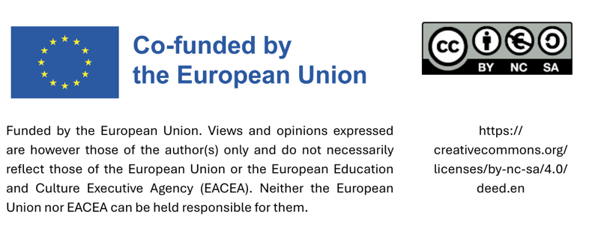

Measure the total hours spent on procurement activities (tender preparation, coordination, supplier communication) for a joint procurement versus if each municipality had procured individually.

