Simulation Game: Possible Problems with
Joint Procurement of Products or Services

The purpose of the simulation is to test and validate the planned joint procurement process across multiple municipalities. Participants can explore potential risks, identify governance gaps, and assess whether roles, responsibilities, and coordination mechanisms are sufficiently defined before implementation.

The simulation is a governance stress test. Instead of discussing processes abstractly, participants take on specific roles and respond to a realistic problem in real time.
Duration: Approximately 2 hours
Participants: Representatives from several municipalities

Simulation Exercise Structure
- Set up (ca. 30 minutes)
- Definition of the problem
The simulation is based on realistic problem situations that requires coordination between the municipalities that participate in the joint procurement. Typical examples for scenarios include for example:
- the sudden insolvency of a key service provider (resulting in an immediate halt of services),
- dissatisfaction among some municipalities with the quality or reliability of a supplier (there could be uneven service-levels),
- unexpected demand spikes that strain the existing agreement.

Possible Scenario: Municipalities participating in a joint procurement for cleaning services report differing levels of satisfaction with the provider’s performance. While some consider the service adequate and in line with agreed standards, others experience recurring issues such as incomplete cleaning, inconsistent delivery, or slow responses to complaints.
These differences create tension within the group and raise questions about common service standards, monitoring, and coordinated complaint handling. The municipalities must jointly assess the situation, align their perspectives, and decide whether and how to take corrective action.

- Assignment of Roles
The following roles are focused on the scenario described above “differing levels of satisfaction with the provider’s performance”.
- Coordinating Municipality (facilitator role): Organises the joint discussion between municipalities, collects and structures feedback from all parties, attempts to align differing perspectives into a common position, does not have formal decision authority over others.
- Satisfied Municipalities (1–3 roles): Report that service quality is acceptable, may prioritise continuity and stability over contract changes, potentially more risk-averse regarding escalation or sanctions, provide evidence of satisfactory performance where applicable.
- Dissatisfied Municipalities (1–3 roles): Report recurring service quality issues, push for corrective action, stricter enforcement, or possible contract adjustments, may demand compensation, improved monitoring, or escalation procedures, experience operational pressure due to service shortcomings.
- Service Provider (Optional Role): Responds to complaints and feedback, explains performance variations (if asked), offers (inadequate) improvement measures or corrective actions, engages in negotiation regarding expectations and obligations.
- Clarification of objectives and rules
Participants are introduced to the objectives of the exercise, the rules of interaction, and the expected outcomes. Any open questions regarding the process, roles, or scenario are clarified to ensure a shared understanding before the simulation begins.

- Play the Scenario (ca. 60 minutes)
In this phase, participants actively engage in the simulated situation based on their assigned roles. They interact with each other, exchange information, and make decisions in real time as the scenario unfolds. The focus is on applying the prepared case conditions to a realistic and dynamic process. Unexpected developments may occur, requiring participants to adapt their actions and responses accordingly.

- Review (ca. 30 minutes)
In this phase, the simulation is reflected upon and jointly analysed. Participants discuss what happened during the scenario and how decisions were made. Key learnings, challenges, and alternative approaches are identified and discussed. The aim is to transfer insights from the simulation to real-world situations.
Notes
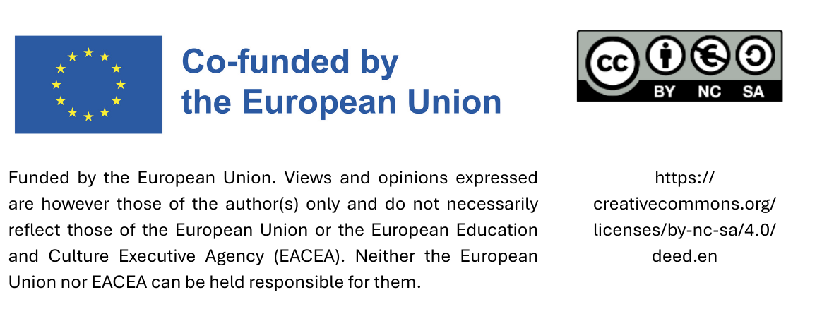
The moderator should actively surface differing perceptions between municipalities and ensure that disagreements are made explicit rather than avoided. The key learning objective is not to “solve” the service issue perfectly, but to understand how joint governance functions under conditions of unequal satisfaction and limited centralised authority.

Rather than including a separate supplier role, it may be stated that the service provider was approached multiple times to improve service quality, but no significant improvements were achieved and no further options for optimization are apparent.

